# Chantera Lazard

Create Scripts

--Products

CREATE TABLE [Products] (

[Product_ID] int NOT NULL,

[Brewery_ID] int NOT NULL,

[Product_Description] varchar(256),

[Product_Price] smallmoney,

[Is_Deleted] bit

);

Go

--Misc_Item

CREATE TABLE [Misc_Item] (

[MiscItem_ID] int IDENTITY(1,1) NOT NULL,

[Product_ID] int NOT NULL,

[ItemType_ID] int NOT NULL,

[Item_Name] varchar(128)

);

Go

--Item_Type

CREATE TABLE [Item_Type] (

[ItemType_ID] int IDENTITY(1,1) NOT NULL,

[Item_Type] varchar(128) NOT NULL

);

Go

--Table Coupon

CREATE TABLE [Coupon] (

[Coupon_Code] varchar(50) NOT NULL,

[Coupon_Value] float NOT NULL,

[Coupon_Unit] varchar(50) NOT NULL,

[Groupon] bit,

[Issue_Date] date,

[Expiration_Date] date,

[Description] varchar(255),

[IsDeleted] bit NOT NULL DEFAULT 0

);

Go

--Table Employee User

CREATE TABLE [Employee_User] (

[EmployeeUser_ID] int IDENTITY(1,1) NOT NULL,

[Employee_ID] int,

[User_ID] int,

[Is_Deleted] bit NOT NULL DEFAULT 0

);

Go

--Table Role

CREATE TABLE [Role] (

[Role_ID] int IDENTITY (0001,1) NOT NULL,

[Role_Name] varchar(128) NOT NULL,

[Role_Description] varchar(256) NOT NULL

);

Go

--Table Permission

CREATE TABLE [Permission] (

[Permission_ID] int IDENTITY(1,1) NOT NULL,

[Role_ID] int NOT NULL,

[Permission_Name] varchar(128) NOT NULL

);

Go

--Table User

CREATE TABLE [User] (

[User_ID] int IDENTITY(0001,1) NOT NULL,

[Role_ID] int NOT NULL,

[Username] varchar(50) NOT NULL,

[Password] varchar(50) NOT NULL,

[Created] datetime,

[Modified] datetime,

);

Go

--Table Customer User

CREATE TABLE [Customer_User] (

[CustomerUser_ID] int IDENTITY(1000,1) NOT NULL,

[Customer_ID] int,

[User_ID] int,

[CustomerProfile_ID] int

);

Alter Scripts – PK

--Products PK

ALTER TABLE [Products] Add

Constraint [PK_Products] PRIMARY KEY ([Product_ID]);

--Misc Items PK

ALTER TABLE [Misc_Item] Add

Constraint [PK_Misc_Item] PRIMARY KEY ([MiscItem_ID]);

--Item_Type

ALTER TABLE [Item_Type] Add

Constraint [PK_Item_Type] PRIMARY KEY ([ItemType_ID]);

--Coupon PK

ALTER TABLE [Coupon] Add

Constraint [PK_Coupon] PRIMARY KEY ([Coupon_Code]);

--Employee User PK

ALTER TABLE [Employee_User] Add

Constraint [PK_Employee_User] PRIMARY KEY ([EmployeeUser_ID]);

--Roles PK

ALTER TABLE [Role] Add

Constraint [PK_Role] PRIMARY KEY ([Role_ID]);

--Permission PK

ALTER TABLE [Permission] Add

Constraint [PK_Permission] PRIMARY KEY ([Permission_ID]);

--User PK

ALTER TABLE [User] Add

Constraint [PK_User] PRIMARY KEY ([User_ID]);

--Customer User PK

ALTER TABLE [Customer_User] Add

Constraint [PK_Customer_User] PRIMARY KEY ([CustomerUser_ID]);

Alter Scripts - FK

--Reference: Klaus Brewing Location -> Products

ALTER TABLE [Products] Add Constraint [FK_Products]

FOREIGN KEY ([Brewery_ID])

REFERENCES [Klaus_Brewing_Locaton] ([Brewery_ID]);

Go

--Reference: Products -> Misc Item

--Reference: Item Type -> Misc Item

ALTER TABLE [Misc_Item] Add Constraint [FK_Misc_Item]

FOREIGN KEY ([Product_ID])

REFERENCES [Products] ([Product_ID]),

Constraint [FK_Misc_Items2]

FOREIGN KEY ([ItemType_ID])

REFERENCES [Item_Type] ([ItemType_ID]);

Go

--Reference: Employee -> Employee User

--Reference: User -> Employee User

ALTER TABLE [Employee_User] Add Constraint [FK_Employee_User]

FOREIGN KEY ([Employee_ID])

REFERENCES [Employee] ([Employee_ID]),

Constraint [FK_Employee_User2]

FOREIGN KEY ([User_ID])

REFERENCES [User] ([User_ID]);

Go

--Reference: Roles -> Users

ALTER TABLE [User] Add Constraint [FK_User]

FOREIGN KEY ([Role_ID])

REFERENCES [Role] ([Role_ID]);

Go

--Reference:Roles -> Permission

ALTER TABLE [Permission] Add Constraint [FK_Permission]

FOREIGN KEY ([Role_ID])

REFERENCES [Role] ([Role_ID]);

Go

--Reference:Customer Profile -> Customer User

--Reference:User -> Customer User

ALTER TABLE [Customer_User] Add Constraint [FK_Customer_User]

FOREIGN KEY ([CustomerProfile_ID])

REFERENCES [Customer_Profile] ([CustomerProfile_ID]),

Constraint [FK_Customer_User2]

FOREIGN KEY ([User_ID])

REFERENCES [User] ([User_ID]);

Bulk Load Scripts

--BULK INSERT [Products]

BULK INSERT [Products]

FROM 'C:\Users\Student\Documents\SQL Server Management Studio\Data\Products_Data.csv'

WITH (

FIELDTERMINATOR = ',',

ROWTERMINATOR = '\n'

);

SELECT * FROM [Products]

--BULK INSERT [Misc_Items]

BULK INSERT [Misc_Item]

FROM 'C:\Users\Student\Documents\SQL Server Management Studio\Data\MiscItems_Data.csv'

WITH (

FIELDTERMINATOR = ',',

ROWTERMINATOR = '\n'

);

SELECT * FROM [Misc_Item]

--BULK INSERT [Item_Type]

BULK INSERT [Item_Type]

FROM 'C:\Users\Student\Documents\SQL Server Management Studio\Data\ItemType_Data.csv'

WITH (

FIELDTERMINATOR = ',',

ROWTERMINATOR = '\n'

);

SELECT * FROM [Item_Type]

--BULK INSERT [Coupon]

BULK INSERT [Coupon]

FROM 'C:\Users\Student\Documents\SQL Server Management Studio\Data\Coupon_Data.csv'

WITH (

FIELDTERMINATOR = ',',

ROWTERMINATOR = '\n'

);

SELECT * FROM [Coupon]

--BULK INSERT [Employee_User]

BULK INSERT [Employee_User]

FROM 'C:\Users\Student\Documents\SQL Server Management Studio\Data\EmployeeUser_Data.csv'

WITH (

FIELDTERMINATOR = ',',

ROWTERMINATOR = '\n'

);

SELECT * FROM [Employee_User]

--BULK INSERT [Role]

BULK INSERT [Role]

FROM 'C:\Users\Student\Documents\SQL Server Management Studio\Data\Role_Data.csv'

WITH (

FIELDTERMINATOR = ',',

ROWTERMINATOR = '\n'

);

SELECT * FROM [Role]

--BULK INSERT [Permission]

BULK INSERT [Permission]

FROM 'C:\Users\Student\Documents\SQL Server Management Studio\Data\Permission_Data.csv'

WITH (

FIELDTERMINATOR = ',',

ROWTERMINATOR = '\n'

);

SELECT * FROM [Permission]

--BULK INSERT [User]

BULK INSERT [User]

FROM 'C:\Users\Student\Documents\SQL Server Management Studio\Data\User_Data.csv'

WITH (

FIELDTERMINATOR = ',',

ROWTERMINATOR = '\n'

);

Data Created

Product Data

1,1,Krug + Core Bier 220z Bottle,25,0

2,1,Krug + Tshirt + 3 Tokens,50,0

3,1,Goblet + Dopplesticke Bottle,20,0

4,1,Goblet + Tshirt + Dopplesticke Bottle,35,0

5,1,Snifter + Vom Fass 22oz Bottle,25,0

6,1,(2) Vom Fass Bottles + 2 Snifters,50,0

7,1,Core Flights,15,0

8,1,Mix Flights,15,0

9,1,Chardonnay,6,0

10,1,Riesling,6,0

11,1,Dornfelder German Semi-Sweet Red,6,0

12,1,Cabernet,6,0

13,1,Diet Coke,2,0

14,1,Coke,2,0

15,1,Sprite,2,0

16,1,Orange Fanta,2,0

17,1,3 Tokens,17,0

18,1,4 Tokens,22,0

19,1,Personal Cheese Pizza,7.5,0

20,1,Personal Pepperoni Pizza,7.5,0

21,1,Woodruff pumps,1,0

22,1,Raspberry pumps,1,0

23,1,Cassis (Black Currant) pumps,1,0

24,1,Woodruff TO GO 1oz cups,2,0

25,1,Raspberry TO GO 1oz cups,2,0

26,1,Cassis (Black Currant) TO GO 1oz cups,2,0

27,1,6 oz Snifter,6.5,0

28,2,8 oz Snifter,8,0

29,1,8.8 oz Pilsner,8.5,0

30,2,11 oz Pilsner,10,0

31,1,13 oz Goblet,15,0

32,2,6 oz Mug,5,0

33,1,30 oz Mug,25,0

34,1,Small Tan Men Klaus ,20,0

35,1,Medium Tan Men Klaus ,20,0

36,1,Large Tan Men Klaus ,20,0

37,1,X-Large Tan Men Klaus ,20,0

38,1,XX-Large Tan Men Klaus ,25,0

39,1,XX-Large Tan Men Klaus ,25,0

40,1,XXX-Large Tan Men Klaus ,25,0

41,1,Small Tan Women Klaus ,20,0

42,1,Medium Tan Women Klaus ,20,0

43,1,Large Tan Women Klaus ,20,0

44,1,Small Black Men Klaus ,20,0

45,1,Medium Black Men Klaus ,20,0

46,1,Large Black Men Klaus ,20,0

47,1,X-Large Black Men Klaus ,20,0

48,1,XX-Large Black Men Klaus ,25,0

49,1,XX-Large BlackMen Klaus ,25,0

50,1,XXX-Large Black Men Klaus ,25,0

51,2,Small Navy Blue Men OktoberFest,20,0

52,2,Medium Navy Blue Men OktoberFest,20,0

53,2,Large Navy Blue Men OktoberFest,20,0

54,2,X-Large Navy Blue Men OktoberFest,20,0

55,2,XX-Large Navy Blue Men OktoberFest ,25,0

56,2,XX-Large Navy Blue Men OktoberFest,25,0

57,2,XXX-Large Navy Blue Men OktoberFest,25,0

58,1,Small Red Women Dunkel,20,0

59,1,Medium Red Women Dunkel,20,0

60,1,Large Red Women Dunkel,20,0

61,1,Small Green Women Edel,20,0

62,1,Medium Green Women Edel,20,0

63,1,Large Green Women Edel,20,0

64,2,Tan Klaus Cap,22,0

65,2,Red Klaus Cap,22,0

66,2,Navy Blue Klaus Cap,22,0

67,2,Tan Dunkel Cap,30,0

68,2,Red Dunkel Cap,30,0

69,2,Black Dunkel Cap,30,0

70,1,Glass 6 oz Core One Helles of a Lager,4,0

71,1,Glass Pint Core One Helles of a Lager,6,0

72,1,Growler 32 oz Core One Helles of a Lager,10,0

73,1,Growler 64 oz Core One Helles of a Lager,20,0

74,1,Growler Gallon Core One Helles of a Lager,40,0

75,1,Bottle 22 oz To Go Core One Helles of a Lager,6,0

76,1,Keg Quarter Barrel Core One Helles of a Lager,105,0

77,1,Keg 50 Liter Core One Helles of a Lager,155,0

78,1,Thursday Stein 1 L Core One Helles of a Lager,6,0

79,1,Wednesday Glass Pint Core One Helles of a Lager,4,0

80,1,Friday Glass Pint Core One Helles of a Lager,4,0

81,1,Glass 6 oz Core Edelweizen,4,0

82,1,Glass Pint Core Edelweizen,6,0

83,1,Growler 32 oz Core Edelweizen,10,0

84,1,Growler 64 oz Core Edelweizen,20,0

85,1,Growler Gallon Core Edelweizen,40,0

86,1,Bottle 22 oz To Go Core Edelweizen,6,0

87,1,Keg Quarter Barrel Core Edelweizen,105,0

88,1,Keg 50 Liter Core Edelweizen,155,0

89,1,Thursday Stein 1 L Core Edelweizen,6,0

90,1,Wednesday Glass Pint Core Edelweizen,4,0

91,1,Friday Glass Pint Core Edelweizen,4,0

92,1,Glass 6 oz Core Wanderlust,4,0

93,1,Glass Pint Core Wanderlust,6,0

94,1,Growler 32 oz Core Wanderlust,10,0

95,1,Growler 64 oz Core Wanderlust,20,0

96,1,Growler Gallon Core Wanderlust,40,0

97,1,Bottle 22 oz To Go Core Wanderlust,6,0

98,1,Keg Quarter Barrel Core Wanderlust,105,0

99,1,Keg 50 Liter Core Wanderlust,155,0

100,1,Thursday Stein 1 L Core Wanderlust,6,0

101,1,Wednesday Glass Pint Core Wanderlust,4,0

102,1,Friday Glass Pint Core Wanderlust,4,0

103,1,Glass 6 oz Core Kaiser Kolsch,4,0

104,1,Glass Pint Core Kaiser Kolsch,6,0

105,1,Growler 32 oz Core Kaiser Kolsch,10,0

106,1,Growler 64 oz Core Kaiser Kolsch,20,0

107,1,Growler Gallon Core Kaiser Kolsch,40,0

108,1,Bottle 22 oz To Go Core Kaiser Kolsch,6,0

109,1,Keg Quarter Barrel Core Kaiser Kolsch,105,0

110,1,Keg 50 Liter Core Kaiser Kolsch,155,0

111,1,Thursday Stein 1 L Core Kaiser Kolsch,6,0

112,1,Wednesday Glass Pint Core Kaiser Kolsch,4,0

113,1,Friday Glass Pint Core Kaiser Kolsch,4,0

114,1,Glass 6 oz Core Drindl Dropper,4,0

115,1,Glass Pint Core Drindl Dropper,6,0

116,1,Growler 32 oz Core Drindl Dropper,10,0

117,1,Growler 64 oz Core Drindl Dropper,20,0

118,1,Growler Gallon Core Drindl Dropper,40,0

119,1,Bottle 22 oz To Go Core Drindl Dropper,6,0

120,1,Keg Quarter Barrel Core Drindl Dropper,105,0

121,1,Keg 50 Liter Core Drindl Dropper,155,0

122,1,Thursday Stein 1 L Core Drindl Dropper,6,0

123,1,Wednesday Glass Pint Core Drindl Dropper,4,0

124,1,Friday Glass Pint Core Drindl Dropper,4,0

125,1,Glass 6 oz Core Dunkel Breakin' My Heart,4,0

126,1,Glass Pint Core Dunkel Breakin' My Heart,6,0

127,1,Growler 32 oz Core Dunkel Breakin' My Heart,10,0

128,1,Growler 64 oz Core Dunkel Breakin' My Heart,20,0

129,1,Growler Gallon Core Dunkel Breakin' My Heart,40,0

130,1,Bottle 22 oz To Go Core Dunkel Breakin' My Heart,6,0

131,1,Keg Quarter Barrel Core Dunkel Breakin' My Heart,105,0

132,1,Keg 50 Liter Core Dunkel Breakin' My Heart,155,0

133,1,Thursday Stein 1 L Core Dunkel Breakin' My Heart,6,0

134,1,Wednesday Glass Pint Core Dunkel Breakin' My Heart,4,0

135,1,Friday Glass Pint Core Dunkel Breakin' My Heart,4,0

136,1,Glass 6 oz Core Pilsnerfest,4,0

137,1,Glass Pint Core Pilsnerfest,6,0

138,1,Growler 32 oz Core Pilsnerfest,10,0

139,1,Growler 64 oz Core Pilsnerfest,20,0

140,1,Growler Gallon Core Pilsnerfest,40,0

141,1,Bottle 22 oz To Go Core Pilsnerfest,6,0

142,1,Keg Quarter Barrel Core Pilsnerfest,105,0

143,1,Keg 50 Liter Core Pilsnerfest,155,0

144,1,Thursday Stein 1 L Core Pilsnerfest,6,0

145,1,Wednesday Glass Pint Core Pilsnerfest,4,0

146,1,Friday Glass Pint Core Pilsnerfest,4,0

147,1,Glass 6 oz Core Old World Kolsch,4,0

148,1,Glass Pint Core Old World Kolsch,6,0

149,1,Growler 32 oz Core Old World Kolsch,10,0

150,1,Growler 64 oz Core Old World Kolsch,20,0

151,1,Growler Gallon Core Old World Kolsch,40,0

152,1,Bottle 22 oz To Go Core Old World Kolsch,6,0

153,1,Keg Quarter Barrel Core Old World Kolsch,105,0

154,1,Keg 50 Liter Core Old World Kolsch,155,0

155,1,Thursday Stein 1 L Core Old World Kolsch,6,0

156,1,Wednesday Glass Pint Core Old World Kolsch,4,0

157,1,Friday Glass Pint Core Old World Kolsch,4,0

158,1,Bottle 22 oz To Go Core Berliner Weisse,4,0

159,1,Glass 6 oz Special Release Weizenbock,6,0

160,1,Glass Pint Special Release Weizenbock,8,0

161,1,Growler 32 oz Special Release Weizenbock,15,0

162,1,Growler 64 oz Special Release Weizenbock,30,0

163,1,Growler Gallon Special Release Weizenbock,50,0

164,1,Bottle 22 oz Special Release Weizenbock,10,0

165,1,Keg Quarter Special Release Weizenbock,115,0

166,1,Keg 50 Liter Special Release Weizenbock,175,0

167,1,Glass 6 oz Special Release Doppelsticke,6,0

168,1,Glass Pint Special Release Doppelsticke,8,0

169,1,Growler 32 oz Special Release Doppelsticke,15,0

170,1,Growler 64 oz Special Release Doppelsticke,30,0

171,1,Growler Gallon Special Release Doppelsticke,50,0

172,1,Bottle 22 oz Special Release Doppelsticke,10,0

173,1,Keg Quarter Special Release Doppelsticke,115,0

174,1,Keg 50 Liter Special Release Doppelsticke,175,0

175,1,Glass 6 oz Special Release Vom Fauss No.3,6,0

176,1,Glass Pint Special Release Vom Fauss No.3,8,0

177,1,Growler 32 oz Special Release Vom Fauss No.3,15,0

178,1,Growler 64 oz Special Release Vom Fauss No.3,30,0

179,1,Growler Gallon Special Release Vom Fauss No.3,50,0

180,1,Bottle 22 oz Special Release Vom Fauss No.3,10,0

181,1,Keg Quarter Special Release Vom Fauss No.3,115,0

182,1,Keg 50 Liter Special Release Vom Fauss No.3,175,0

183,1,Glass 6 oz Special Release Vom Fauss No.3 Vanilla,6,0

184,1,Glass Pint Special Release Vom Fauss No.3 Vanilla,8,0

185,1,Growler 32 oz Special Release Vom Fauss No.3 Vanilla,15,0

186,1,Growler 64 oz Special Release Vom Fauss No.3 Vanilla,30,0

187,1,Growler Gallon Special Release Vom Fauss No.3 Vanilla,50,0

188,1,Bottle 22 oz Special Release Vom Fauss No.3 Vanilla,10,0

189,1,Keg Quarter Special Release Vom Fauss No.3 Vanilla,115,0

190,1,Keg 50 Liter Special Release Vom Fauss No.3 Vanilla,175,0

191,1,Glass 6 oz Tour of Europe India Pale Lager (IPL),5,0

192,1,Glass Pint Tour of Europe India Pale Lager (IPL),7,0

193,1,Growler 32 oz Tour of Europe India Pale Lager (IPL),13,0

194,1,Growler 64 oz Tour of Europe India Pale Lager (IPL),20,0

195,1,Growler Gallon Tour of Europe India Pale Lager (IPL),45,0

196,1,Bottle 22 oz Tour of Europe India Pale Lager (IPL),7,0

197,1,Keg Quarter Tour of Europe India Pale Lager (IPL),113,0

198,1,Keg 50 Liter Tour of Europe India Pale Lager (IPL),165,0

199,1,Glass 6 oz Tour of Europe Saison,5,0

200,1,Glass Pint Tour of Europe Saison,7,0

201,1,Growler 32 oz Tour of Europe Saison,13,0

202,1,Growler 64 oz Tour of Europe Saison,20,0

203,1,Growler Gallon Tour of Europe Saison,45,0

204,1,Bottle 22 oz Tour of Europe Saison,7,0

205,1,Keg Quarter Tour of Europe Saison,113,0

206,1,Keg 50 Liter Tour of Europe Saison,165,0

207,2,Glass 6 oz Core One Helles of a Lager,4,0

208,2,Glass Pint Core One Helles of a Lager,6,0

209,2,Growler 32 oz Core One Helles of a Lager,10,0

210,2,Growler 64 oz Core One Helles of a Lager,20,0

211,2,Growler Gallon Core One Helles of a Lager,40,0

212,2,Bottle 22 oz To Go Core One Helles of a Lager,6,0

213,2,Keg Quarter Barrel Core One Helles of a Lager,105,0

214,2,Keg 50 Liter Core One Helles of a Lager,155,0

215,2,Thursday Stein 1 L Core One Helles of a Lager,6,0

216,2,Wednesday Glass Pint Core One Helles of a Lager,4,0

217,2,Friday Glass Pint Core One Helles of a Lager,4,0

218,2,Glass 6 oz Core Edelweizen,4,0

219,2,Glass Pint Core Edelweizen,6,0

220,2,Growler 32 oz Core Edelweizen,10,0

221,2,Growler 64 oz Core Edelweizen,20,0

222,2,Growler Gallon Core Edelweizen,40,0

223,2,Bottle 22 oz To Go Core Edelweizen,6,0

224,2,Keg Quarter Barrel Core Edelweizen,105,0

225,2,Keg 50 Liter Core Edelweizen,155,0

226,2,Thursday Stein 1 L Core Edelweizen,6,0

227,2,Wednesday Glass Pint Core Edelweizen,4,0

228,2,Friday Glass Pint Core Edelweizen,4,0

229,2,Glass 6 oz Core Wanderlust,4,0

230,2,Glass Pint Core Wanderlust,6,0

231,2,Growler 32 oz Core Wanderlust,10,0

232,2,Growler 64 oz Core Wanderlust,20,0

233,2,Growler Gallon Core Wanderlust,40,0

234,2,Bottle 22 oz To Go Core Wanderlust,6,0

235,2,Keg Quarter Barrel Core Wanderlust,105,0

236,2,Keg 50 Liter Core Wanderlust,155,0

237,2,Thursday Stein 1 L Core Wanderlust,6,0

238,2,Wednesday Glass Pint Core Wanderlust,4,0

239,2,Friday Glass Pint Core Wanderlust,4,0

240,2,Glass 6 oz Core Kaiser Kolsch,4,0

241,2,Glass Pint Core Kaiser Kolsch,6,0

242,2,Growler 32 oz Core Kaiser Kolsch,10,0

243,2,Growler 64 oz Core Kaiser Kolsch,20,0

244,2,Growler Gallon Core Kaiser Kolsch,40,0

245,2,Bottle 22 oz To Go Core Kaiser Kolsch,6,0

246,2,Keg Quarter Barrel Core Kaiser Kolsch,105,0

247,2,Keg 50 Liter Core Kaiser Kolsch,155,0

248,2,Thursday Stein 1 L Core Kaiser Kolsch,6,0

249,2,Wednesday Glass Pint Core Kaiser Kolsch,4,0

250,2,Friday Glass Pint Core Kaiser Kolsch,4,0

251,2,Glass 6 oz Core Drindl Dropper,4,0

252,2,Glass Pint Core Drindl Dropper,6,0

253,2,Growler 32 oz Core Drindl Dropper,10,0

254,2,Growler 64 oz Core Drindl Dropper,20,0

255,2,Growler Gallon Core Drindl Dropper,40,0

256,2,Bottle 22 oz To Go Core Drindl Dropper,6,0

257,2,Keg Quarter Barrel Core Drindl Dropper,105,0

258,2,Keg 50 Liter Core Drindl Dropper,155,0

259,2,Thursday Stein 1 L Core Drindl Dropper,6,0

260,2,Wednesday Glass Pint Core Drindl Dropper,4,0

261,2,Friday Glass Pint Core Drindl Dropper,4,0

262,2,Glass 6 oz Core Dunkel Breakin' My Heart,4,0

263,2,Glass Pint Core Dunkel Breakin' My Heart,6,0

264,2,Growler 32 oz Core Dunkel Breakin' My Heart,10,0

265,2,Growler 64 oz Core Dunkel Breakin' My Heart,20,0

266,2,Growler Gallon Core Dunkel Breakin' My Heart,40,0

267,2,Bottle 22 oz To Go Core Dunkel Breakin' My Heart,6,0

268,2,Keg Quarter Barrel Core Dunkel Breakin' My Heart,105,0

269,2,Keg 50 Liter Core Dunkel Breakin' My Heart,155,0

270,2,Thursday Stein 1 L Core Dunkel Breakin' My Heart,6,0

271,2,Wednesday Glass Pint Core Dunkel Breakin' My Heart,4,0

272,2,Friday Glass Pint Core Dunkel Breakin' My Heart,4,0

273,2,Glass 6 oz Core Pilsnerfest,4,0

274,2,Glass Pint Core Pilsnerfest,6,0

275,2,Growler 32 oz Core Pilsnerfest,10,0

276,2,Growler 64 oz Core Pilsnerfest,20,0

277,2,Growler Gallon Core Pilsnerfest,40,0

278,2,Bottle 22 oz To Go Core Pilsnerfest,6,0

279,2,Keg Quarter Barrel Core Pilsnerfest,105,0

280,2,Keg 50 Liter Core Pilsnerfest,155,0

281,2,Thursday Stein 1 L Core Pilsnerfest,6,0

282,2,Wednesday Glass Pint Core Pilsnerfest,4,0

283,2,Friday Glass Pint Core Pilsnerfest,4,0

284,2,Glass 6 oz Core Old World Kolsch,4,0

285,2,Glass Pint Core Old World Kolsch,6,0

286,2,Growler 32 oz Core Old World Kolsch,10,0

287,2,Growler 64 oz Core Old World Kolsch,20,0

288,2,Growler Gallon Core Old World Kolsch,40,0

289,2,Bottle 22 oz To Go Core Old World Kolsch,6,0

290,2,Keg Quarter Barrel Core Old World Kolsch,105,0

291,2,Keg 50 Liter Core Old World Kolsch,155,0

292,2,Thursday Stein 1 L Core Old World Kolsch,6,0

293,2,Wednesday Glass Pint Core Old World Kolsch,4,0

294,2,Friday Glass Pint Core Old World Kolsch,4,0

Misc Item Data

1,1,1,Krug + Core Bier 220z Bottle

2,2,1,Krug + Tshirt + 3 Tokens

3,3,1,Goblet + Dopplesticke Bottle

4,4,1,Goblet + Tshirt + Dopplesticke Bottle

5,5,1,Snifter + Vom Fass 22oz Bottle

6,6,1,(2) Vom Fass Bottles + 2 Snifters

7,7,2,Core Flights

8,8,2,Mix Flights

9,9,3,Chardonnay

10,10,3,Riesling

11,11,3,Dornfelder German Semi-Sweet Red

12,12,3,Cabernet

13,13,4,Diet Coke

14,14,4,Coke

15,15,4,Sprite

16,16,4,Orange Fanta

17,17,5,3 Tokens

18,18,5,4 Tokens

19,19,6,Personal Cheese Pizza

20,20,6,Personal Pepperoni Pizza

21,21,7,Woodruff pumps

22,22,7,Raspberry pumps

23,23,7,Cassis (Black Currant) pumps

24,24,7,Woodruff TO GO 1oz cups

25,25,7,Raspberry TO GO 1oz cups

26,26,7,Cassis (Black Currant) TO GO 1oz cups

Item Type Data

1,Gift Sets

2,Flights

3,Wine

4,Soda

5,Tokens

6,Food

7,Syrup

Coupon Data

KLAUS20,20,percentage,0,1/1/2016,2/1/2016,20% off any core bier,1

1BEERONME,6,USD,0,10/1/2020,10/31/2020,1 Free Pint of Core Bier,0

A346MA,26,percentage,1,5/25/2020,10/31/2020,26% off full purchase,0

50OFFMERCH,50,percentage,0,11/1/2020,11/30/2020,50% off all merchandise,0

ILOVEKLAUS,5,USD,0,9/29/2020,10/31/2020,5 dollars off purchase,0

16892034T,27,percentage,0,7/31/2020,7/31/2020,"Happy Birthday! Since you are 27, you get 27% off purchase",0

G09KMDLA,10,USD,1,10/31/2020,10/31/2020,Happy Halloween! 10 dollars off your total today.,0

BUY1GET50OFF,50,percentage,0,8/31/2020,12/31/2020,"Buy 1 special release bier, get 50% off another special release bier",0

KLAUS40,40,dollars,0,7/31/2020,8/31/2020,40 dollars off any keg purchases,1

Employee User Data

1,159753,1001,0

2,159752,1002,0

3,159751,1003,0

Role Data

1,Employee,Employee clearance

2,Customer,Customer clearance

Permission Data

1,1,View Profiles

2,1,Transactions

3,1,Creating Reports

4,1,Add Employee Access

5,1,Create Products

6,1,Update Products

7,1,Delete Products

8,1,Insert Klaus Brewing Locations

9,1,Update Klaus Brewing Locations

10,1,Delete Klaus Brewing Locations

11,1,Delete any Customer Profiles

12,1,View all Customer Profiles

13,1,View all Contact Information

14,1,View all Orders

15,1,View all Order Details

16,1,View all Redemption History

17,1,View all Rewards

18,1,Delete Rewards

19,1,Update Rewards

20,1,Insert Rewards

21,2,View Customer Profile

22,2,View Order History

23,2,View Order Details

24,2,View Contact Information

25,2,View Rewards

26,2,View Remption History

User Data

1,1,booker12,12se74,2020-10-01,

2,1,grey07,04ap67,2020-10-01,

3,1,johnson81," 30no86",2020-10-01,

4,2,jenkins46,14ju73,2020-10-01,

5,2,smith79,09ja61,2020-10-02,2020-10-09

6,2,login12,rb9012,2020-10-03,

7,2,login11,lg2070,2020-10-04,

8,2,login13,cj4081,2020-10-05,

9,2,login14,mj9346,2020-10-06,

10,2,login15,js5079,2020-10-07,

11,2,login16,password!,2020-10-08,

12,2,login17,Welcome123,2020-10-09,

13,2,login18,L12345,2020-10-10,

14,2,login19,qwerty,2020-10-11,

15,2,login20,Password1,2020-10-01,

16,2,login21,Password2,2020-10-12,

17,2,login22,Password3,2020-10-13,

18,2,login23,Password4,2020-10-14,

19,2,login24,Password5,2020-10-01,

20,2,login25,Password6,2020-10-09,

21,2,login26,Password7,2020-10-10,

22,2,login27,Password8,2020-10-11,

23,2,login28,Password9,2020-10-01,

24,2,login29,Password10,2020-10-02,

25,2,login30,Password11,2020-10-01,

26,2,login31,Password12,2020-10-09,

27,2,login32,Password13,2020-10-10,

28,2,login33,Password14,2020-10-11,

29,2,login34,Password15,2020-10-01,

30,2,login35,Password16,2020-10-02,

31,2,login36,Password17,2020-10-03,

32,2,login37,Password18,2020-10-04,

33,2,login38,Password19,2020-10-05,

34,2,login39,Password20,2020-10-06,

35,2,login40,Password21,2020-10-07,

36,2,login41,Password22,2020-10-08,

37,2,login42,Password23,2020-10-09,

38,2,login43,Password24,2020-10-10,

39,2,login44,Password25,2020-10-11,

40,2,login45,Password26,2020-10-01,

41,2,login46,Password27,2020-10-02,

42,2,login47,Password28,2020-10-03,

43,2,login48,Password29,2020-10-04,

44,2,login49,Password30,2020-10-05,

45,2,login50,Password31,2020-10-06,

46,2,login51,Password32,2020-10-07,2020-10-20

47,2,login52,Password33,2020-10-08,

48,2,login53,Password34,2020-10-29,

49,2,login54,Password35,2020-10-20,

50,2,login55,Password36,2020-10-21,

51,2,login56,Password37,2020-10-06,

52,2,login57,Password38,2020-10-07,

53,2,login58,Password39,2020-10-08,

54,2,login59,Password40,2020-10-09,

55,2,login60,Password41,2020-10-10,

56,2,login61,Password42,2020-10-11,

57,2,login62,Password43,2020-10-01,

58,2,login63,Password44,2020-10-01,

59,2,login64,Password45,2020-10-01,

60,2,login65,Password46,2020-10-01,

61,2,login66,Password47,2020-10-01,

62,2,login67,Password48,2020-10-01,

63,2,login68,Password49,2020-10-01,

64,2,login69,Password50,2020-10-01,

65,2,login70,Password51,2020-10-01,

66,2,login71,Password52,2020-10-01,

67,2,login72,Password53,2020-10-09,

68,2,login73,Password54,2020-10-10,

69,2,login74,Password55,2020-10-11,

70,2,login75,Password56,2020-10-01,

71,2,login76,Password57,2020-10-02,

72,2,login77,Password58,2020-10-03,

73,2,login78,Password59,2020-10-04,2020-10-04

74,2,login79,Password60,2020-10-05,

75,2,login80,Password61,2020-10-06,

76,2,login81,Password62,2020-10-07,

77,2,login82,Password63,2020-10-08,

78,2,login83,Password64,2020-10-09,

79,2,login84,Password65,2020-10-10,

80,2,login85,Password66,2020-10-11,

81,2,login86,Password67,2020-10-12,

82,2,login87,Password68,2020-10-13,

83,2,login88,Password69,2020-10-14,

84,2,login89,Password70,2020-10-15,

85,2,login90,Password71,2020-10-16,

86,2,login91,Password72,2020-10-17,

87,2,login92,Password73,2020-10-18,

88,2,login93,Password74,2020-10-19,

89,2,login94,Password75,2020-10-20,

90,2,login95,Password76,2020-10-21,

91,2,login96,Password77,2020-10-22,

92,2,login97,Password78,2020-10-09,

93,2,login98,Password79,2020-10-10,

94,2,login99,Password80,2020-10-11,2020-10-15

95,2,login100,Password81,2020-10-01,

96,2,login101,Password82,2020-10-02,

97,2,login102,Password83,2020-10-03,

98,2,login103,Password84,2020-10-04,

99,2,login104,Password85,2020-10-05,

100,2,login105,Password86,2020-10-06,2020-10-10

101,2,login106,Password87,2020-10-07,

102,2,login107,Password88,2020-10-08,

0103,2,login108,Password89,2020-10-08,

Customer User Data

1000,1111,0004,1

1001,2222,0005,2

1002,3333,0006,3

1003,4444,0007,4

1004,5555,0008,5

1005,6666,0009,6

1006,7777,0010,7

1007,8888,0011,8

1008,9999,0012,9

1009,11110,0013,10

1010,12221,0014,11

1011,13332,0015,12

1012,14443,0016,13

1013,15554,0017,14

1014,16665,0018,15

1015,17776,0019,16

1016,18887,0020,17

1017,19998,0021,18

1018,21109,0022,19

1019,22220,0023,20

1020,23331,0024,21

1021,24442,0025,22

1022,25553,0026,23

1023,26664,0027,24

1024,27775,0028,25

1025,28886,0029,26

1026,29997,0030,27

1027,31108,0031,28

1028,32219,0032,29

1029,33330,0033,30

1030,34441,0034,31

1031,35552,0035,32

1032,36663,0036,33

1033,37774,0037,34

1034,38885,0038,35

1035,39996,0039,36

1036,41107,0040,37

1037,42218,0041,38

1038,43329,0042,39

1039,44440,0043,40

1040,45551,0044,41

1041,46662,0045,42

1042,47773,0046,43

1043,48884,0047,44

1044,49995,0048,45

1045,51106,0049,46

1046,52217,0050,47

1047,53328,0051,48

1048,54439,0052,49

1049,55550,0053,50

1050,56661,0054,51

1051,57772,0055,52

1052,58883,0056,53

1053,59994,0057,54

1054,61105,0058,55

1055,62216,0059,56

1056,63327,0060,57

1057,64438,0061,58

1058,65549,0062,59

1059,66660,0063,60

1060,67771,0064,61

1061,68882,0065,62

1062,69993,0066,63

1063,71104,0067,64

1064,72215,0068,65

1065,73326,0069,66

1066,74437,0070,67

1067,75548,0071,68

1068,76659,0072,69

1069,77770,0073,70

1070,78881,0074,71

1071,79992,0075,72

1072,81103,0076,73

1073,82214,0077,74

1074,83325,0078,75

1075,84436,0079,76

1076,85547,0080,77

1077,86658,0081,78

1078,87769,0082,79

1079,88880,0083,80

1080,89991,0084,81

1081,91102,0085,82

1082,92213,0086,83

1083,93324,0087,84

1084,94435,0088,85

1085,95546,0089,86

1086,96657,0090,87

1087,97768,0091,88

1088,98879,0092,89

1089,99990,0093,90

1090,101101,0094,91

1091,102212,0095,92

1092,103323,0096,93

1093,104434,0097,94

1094,105545,0098,95

1095,106656,0099,96

1096,107767,0100,97

1097,108878,0101,98

1098,109989,0102,99

1099,111100,0103,100

*SQL Queries*

Business Report 1

**Report Name:** Order Details

**Report Description:** Selects order details for a specific order

**Business Purpose:** The client requests to see order details in order to investigate the order as well as for future purposes such as a discrepancy concern with the customer. They can just pull up the order and verify any information needed

**SQL CODE:**

Use [Klaus Loyalty Program]

DECLARE

@brewofInt int,

@OrderofInt int

SELECT @OrderofInt = '1234'

SELECT [Order].Order_ID,

[Products].Product_Description,

[Products].Product_Price

FROM [Order]

JOIN [Order Details] ON [Order].Order_ID = [Order Details].Order_ID

JOIN [Products] ON [Products].Product_ID = [Order Details].Product_ID

WHERE [Order].Order_ID = @OrderofInt

**Report/Query Results:**

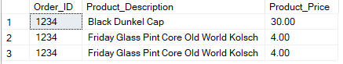

**Tables Referenced:**

**Order Table**

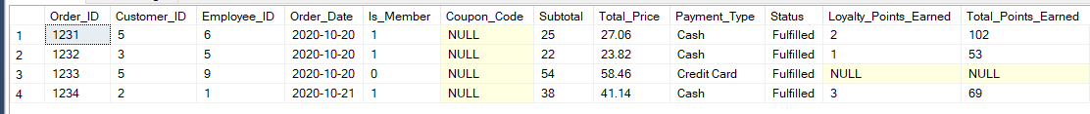

**Order Details**

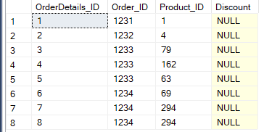

**Partial Product Table (1-17 items of 294)**

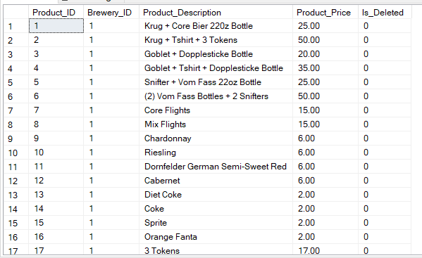

Business Report 2

**Report Name:** Database Administrations

**Report Description:** Lists the name of the Employee Administrations

**Business Purpose:** The client requests to see the name of the employees who have admin rights to make changes in the database.

**SQL CODE:**

DECLARE

@roleofint int

SELECT @roleofint = 1

SELECT [EmployeeInformation].First_name,

[EmployeeInformation].Last_name,

[Employee].Employee_Title

FROM [EmployeeInformation]

JOIN [Employee] ON [EmployeeInformation].Employee_ID = [Employee].Employee_ID

JOIN [Employee_User] ON [Employee_User].Employee_ID = [Employee].Employee_ID

JOIN [User] ON [User].User_ID = [Employee_User].User_ID

JOIN [Role] ON [Role].Role_ID = [User].Role_ID

WHERE [Role].Role_ID = @roleofint

**Report/Query Results:**

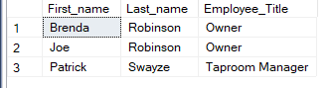

**Tables Referenced:**

**Employee Information**

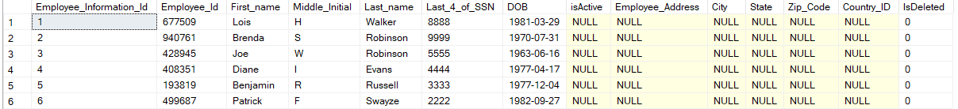

**Employee**

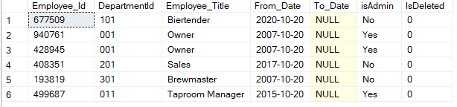

**Employee User**

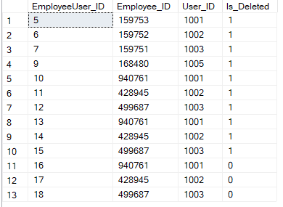

**Role**

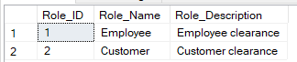

Business Report 3

**Report Name:** Gift Sets

**Report Description:** Lists the Gift Sets

**Business Purpose:** The client specifically requested the ability to pull up specific products to analyze what is still active and prices.

**SQL CODE:**

DECLARE

@ItemofInt int

SELECT @ItemofInt = '1'

SELECT [Products].Product_Description,

[Products].Product_Price,

[Products].Is_Deleted

FROM [Products]

JOIN [Misc_Item] ON [Misc_Item].Product_ID = [Products].Product_ID

JOIN [Item_Type] ON [Item_Type].ItemType_ID = [Misc_Item].ItemType_ID

WHERE [Item_Type].ItemType_ID = @ItemofInt

**Report/Query Results:**

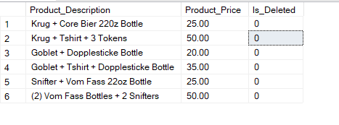

**Tables Referenced:**

**Partial Products (1-17 out of 294 items)**



**Misc Items**

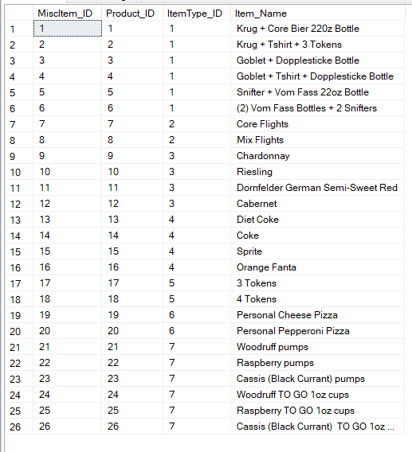

**Item Type**

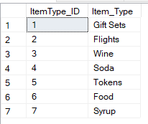

Business Report 4

**Report Name:** Redemption History

**Report Description:** Lists a customer’s redemption history

**Business Purpose:** The client would like to see the redemption history of particular customer too see what they favor. They might also want to see which reward is a favorite among customers. Lastly, it is also for customers to track their redemption history.

**SQL CODE:**

Use [Klaus Loyalty Program]

DECLARE

@CustOfInt INT

SELECT @CustOfInt ='2'

SELECT [Customer Info].Customer_First,

[Customer Info].Customer_Last,

[Rewards].Reward_Description,

[Rewards].Redemption_Cost

FROM [Customer Info]

JOIN [Customer_User] ON [Customer_User].Customer_ID = [Customer Info].Customer_ID

JOIN [Customer_Profile] ON [Customer_Profile].CustomerProfile_ID = Customer_User.CustomerProfile_ID

JOIN [Redemption_History] ON [Redemption_History].CustomerProfile_ID = Customer_Profile.CustomerProfile_ID

JOIN [Rewards] ON Rewards.Reward_ID = Redemption_History.Reward_ID

WHERE Customer_Profile.CustomerProfile_ID = @CustOfInt

**Report/Query Results:**

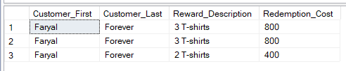

**Tables Referenced:**

**Customer Information**

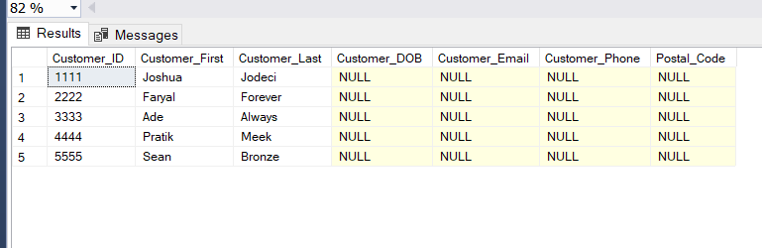

**Customer User**

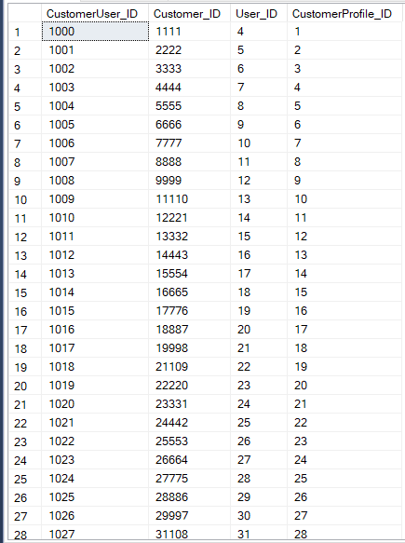

**Customer Profile**



**Redemption History**

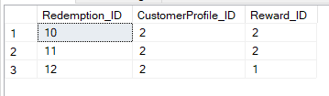

**Rewards**

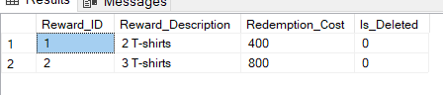

SQL Update Scripts

Insert Scripts

INSERT INTO [Employee_User] ([Employee_ID], [User_ID])

VALUES ('168489', '1005');

|  |
| --- |
| BEFORE |
|  |
|  |
| **AFTER** |
|  |
|  |

INSERT INTO [Coupon] ([Coupon_Code], [Coupon_Value], [Coupon_Unit], [Groupon])

VALUES ('KB168945', '20', 'percent', '0');

|  |
| --- |
| BEFORE |
|  |
| **AFTER** |
|  |

Update Scripts

UPDATE [Employee_User]

SET [Employee_ID] = '168480'

WHERE [EmployeeUser_ID] = 8;

|  |
| --- |
| BEFORE |
|  |
| **AFTER** |
|  |

UPDATE [Coupon]

SET [Coupon_Value] = '30', Groupon = '1', Issue_Date = '2020-10-22'

WHERE [Coupon_Code] = 'KB168945';

|  |
| --- |
| BEFORE |
|  |
| **AFTER** |
|  |

Delete Scripts

Trigger Script

CREATE OR ALTER TRIGGER SoftDelete_EmployeeUser ON [Employee_User]

INSTEAD OF DELETE AS

BEGIN

SET NOCOUNT ON;

UPDATE [Employee_User]

SET [Is_Deleted] = 1

WHERE [EmployeeUser_ID] IN (SELECT [EmployeeUser_ID] FROM DELETED);

END

GO

Delete Script

DELETE FROM [Employee_User] WHERE [EmployeeUser_ID] = '9';

|  |
| --- |
| BEFORE |
|  |
| **AFTER** |
|  |

Trigger Script

CREATE OR ALTER TRIGGER SoftDelete_Coupon ON [Coupon]

INSTEAD OF DELETE AS

BEGIN

SET NOCOUNT ON;

UPDATE [Coupon]

SET [IsDeleted] = 1

WHERE [Coupon_Code] IN (SELECT [Coupon_Code] FROM DELETED);

END

GO

Delete Script

DELETE FROM [Coupon] WHERE [Coupon_Code] = 'KB168945';

|  |
| --- |
| BEFORE |
|  |
| **AFTER** |
|  |